A000-MEX-Mezcala-Head-Brown Basalt-300 BCE

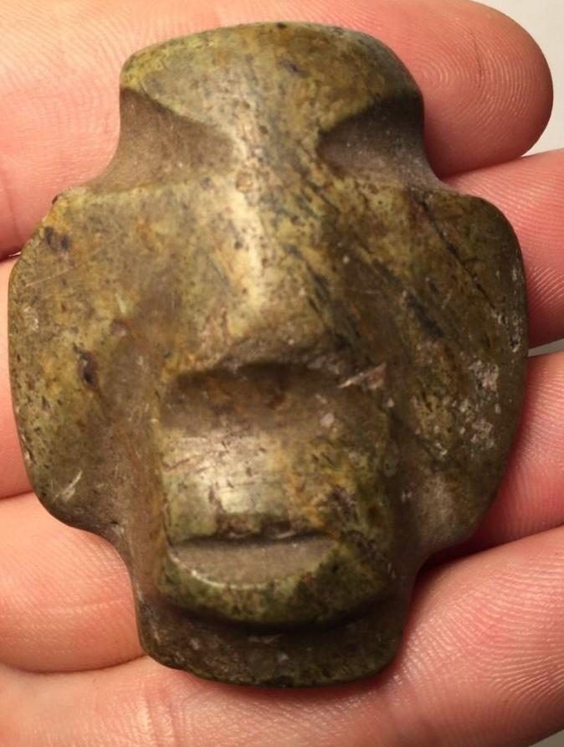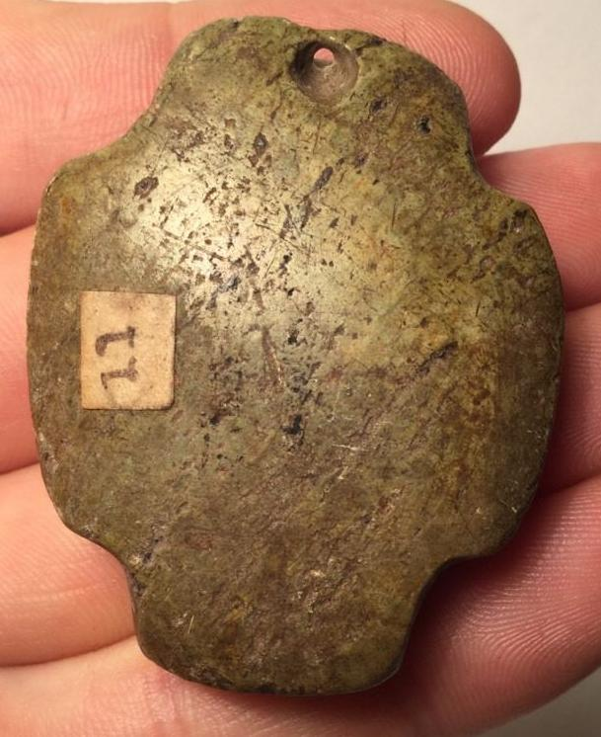

Case No.: 14

**Accession No.**

**Formal Label:** MEX-Mezcala-Head-Brown Basalt-300 BCE

**Display Description:**

**LC Classification:**

**Date or Time Horizon:**

**Geographical Area:**

**Map:**

**GPS coordinates:**

**Cultural Affiliation:**

**Media:**

**Dimensions:**

**Weight:**

**Condition:**

**Provenance: Ex David Niven**

**Discussion:**

**References:**

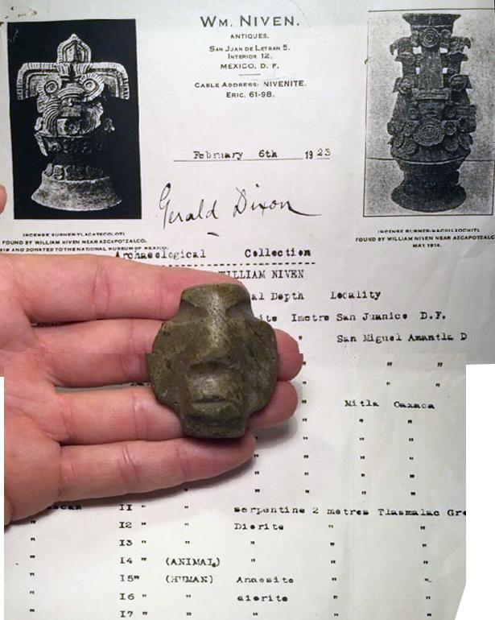

Ok. How many Mezcala have you seen with documented 1920s provenance including the area found? Zero. Found at San Miguel Amantla at a depth of 2 meters.

2" tall includes a copy of paperwork.

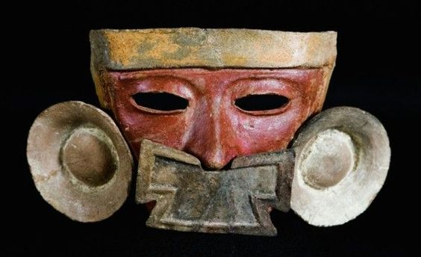

Teotihuacan mask of Azcapotzalco, San Miguel Amantla, Classical period, late Xolalpan phase, Source: Museo Nacional de Antropología Mexico